Methods:

Shrub microsites were defined as underneath the dripline of the shrub. These were located on the south side to minimize shading. Open microsites were located at least 1.5 m from the edge of the dripline of any larrea individual in a paired fashion with the shrub sites.

Each study day, *Malacothrix glabrata* from naturally occurring, nearby populations where it coexists with *Larrea tridentata* were transplanted into 15 cm black pots. Transplants with similar floral number, size and habit were paired. These pairs were placed in the shrub and open microsites, one potted plant per microsite. Six shrub/open pairs were tested each day for 20 days, between the hours of 11:30 and 3:30 to maximize pollinator activity. 10 days (60 shrubs) were tested prior to the shrub blooming, and the same shrubs were retested after entering full bloom. In one or two cases, an earlier tested shrub did not bloom and so was replaced by a blooming shrub. *Larrea tridentata* with fewer than five open blooms were considered non-blooming, average number of blooms for ‘blooming’ treatment was 300.2 ± 176.72SD. The minimum tested was 102, the maximum was 1080. The shrub flowers were counted the same time as the cameras were deployed. The number of blooms of the *Malacothrix* were snipped to equal between shrub and open sites, but left to vary between replicates, except for the first two days of the study. The number of blooming heterospecific shrubs and cacti were counted within a 2 m radius of each the shrub and the open microsite. Annual floral density, percent vegetation cover and species richness were counted within a 0.5 m2 quadrat in each shrub and open microsite.

Polaroid Cube+ HD cameras were used to record pollinator activity on the potted *Malacothrix*. Most videos averaged 1.5 hours in length. These were reviewed in lab. Pollinator visitation was tracked, number of flowers visited, time spent on flower, behaviour and identity of visitor. A pollinator visits was when an insect flew onto the flower. We also tracked when insects crawled onto the flower. Visitation rates are a commonly used proxy of pollination (cite).

Arthropod community sampling

Pan traps were used to quantify pollinator communities associated with the shrub/open microsites, as well as aid identification in videos. Solo brand 6 inch plastic bowls. The colour of the pan traps are yellow, white and blue. They were placed in the same pairwise fashion as the cameras on the same shrubs. They were placed in a triangular shape, and the order of the colours varied. Shrubs were videoed and pan trapped on different days as to not influence pollinator visitation to *Malacothrix*. The pantraps were filled with water with a few drops of Dawn original dish detergent. They were placed by 10 am at the latest morning, and picked up after 5:30 pm to capture peak pollinator activity. The insects were stored in 91% isopropyl alcohol. There are 9 days of pan traps pre-blooming and 10 days post-blooming. Placed under 6 shrub/open pairs per day. They were only placed on sunny days. The insects were pinned and dried to aid identification. Small specimens were identified while in ethanol. Mites were not counted at all. Used a variety of books to help ID. Bees, wasps and syrphid flies were IDed to genus, rest to family except thrips and spiders. Only adult insects were included in the analyses. The specimens are located within our collection in Lortie Lab at York University. Each pinned specimen has unique ID. Specimen list available at: some online repo (KNB?).

Visitation

Insect use and pollinator visitation was tracked to *L. tridentata* as well. Each *L. tridentata* was observed for a 15-minute period, before and after blooming. The number of visits and identity of the visitors were recorded. Visitors were collected when possible to aid identification. The part of the plant that was visited was recorded (branch, flower, understory – which includes the ground itself and plants growing under the shrub), and the general behaviour of the visitor – landing, touchdown (land then fly away), hovering/inspecting, crawling (understory only).

Microclimate

To quantify the microclimates of the microsites, 16 HOBO pendant data loggers were used to record temperature and light availability. Eight loggers were placed under *L. tridentata* and eight in open areas for two months.

Pollen deposition

To quantify how pollen deposition changes with proximity of L. tridentata, I collected stigma from Malacothrix at a nearby site (3 km) with a naturally occurring population of Malacothrix and L. tridentata. It was not possible to do this at my main study site because I could not ensure that the Malacothrix had not been pollinated prior to moving them to my site.

I collected three stigma from each of three flowers from one Malacothrix (nine stigmas per plant) growing each of under the dripline and in a nearby open area, 298 in total. Open area at least 1 m away from dripline of any larrea. Only 13 pairs were tested because a heatwave followed by a wind storm killed the Malacothrix. The distances to the three closest Malacothrix neighbours were measured and to the nearest L. tridentata. The number of Malacothrix flowers per plant were counted, and each Larrea was rated on a Likert scale (1 to 5) to quantify how in bloom it is. The x, y and z were quantified – this with the Likert scale forms a proxy for the number of flowers. The stigmas were stored individually in micro centrifuge tubes filled with denatured alcohol.

The tubes were spun down in a centrifuge at 4200 rpm for 4.5 minutes and the pellet pipetted onto the slide. This along with the stigma were mounted in fuchsin jelly (Kearns book).

At 100 x magnification, 10 longitudinal transects(18 mm by x mm) of pollen were counted per slide. Heterospecific pollen grains were imaged using a Canon 60D SLR with 60mm macro lens into microscope afocally. All stigma were also imaged.

Heterospecific pollen were identified using a reference collection created of 38 species from surrounding sites in 2017 and 2018. This reference collection was photographed using Lumenera microscope camera at 100 x and 400x and the size of grains were measured using Infinity Analyze to aid identification. The digitized reference collection was uploaded to global pollen project (DOI) and the slides are in Lortie Lab at York University.

Weather data

A weather station (link to granites site) in the adjacent Granite Cove provided hourly environmental data. Data logged between 10 am and 5:00 pm were used to correspond with study timings. The mean of hourly wind speed (m/s), mean temperature (ºC) and mean solar radiation were calculated for that time period daily.

Analysis

Video test

We converted visits per hour to standardize visitation across observation periods. It is not uncommon to convert to visits/hour/flower, however this makes the assumption that pollinators respond linearly to the number of flowers and that the slope of the relationship does not change with any treatment. We fitted a GLMM and included both shrub floral number and pot flowers as potential explanatory variables. Because of the repeated measures study design – and that the microsites showed significant correlation, we included the shrub identifier as a random effect. We built models for visitors that fly on and all visitors separately. I assume that visitors that fly on are better pollinators. We also calculated average number of flower visits per foraging bout, and unique flower visits per bout, and average time spent on a flower.

Pan traps

GLMM, again shrub identifier as a random effect. The data showed overdispersion and thus we used a quasi-Poisson approach. We fit the models using a blah blah likelihood something. Beetles from the family Melyridae made up 1/3 of the total arthropods captured, so we ran analyses with them excluded, included and them on their own because their high numbers really swamped out the responses from other insects.

Diversity indices were calculated using the r package vegan. To see if communities were different under shrubs, used rda ordination methods.

Pollen

**Results**

Camera test

Overall, visitation was low (Table 2). A total of 697 flying floral visitors were recorded from 303 hours of video observation. 60 or so observation periods had no flying visitors. See supplemental data for results with all insects touching the flowers.

Mean plant visits per hour. This is just the mean number of potential foraging bouts. ± the standard deviation. This data is super overdispersed!

|  |  |  |
| --- | --- | --- |
|  | Open | Shrub |
| Pre-blooming | 4.2955249 ± 4.621614 | 2.9976793 ± 3.134733 |
| Blooming | 1.2526164 ± 1.376179 | 0.9458532 ± 1.271302 |

Mean number of flowers visited per hour. ± standard deviation. This is also over dispersed ☹

|  |  |  |
| --- | --- | --- |
|  | Open | Shrub |
| Pre-blooming | 5.758404 ± 7.547992 | 3.776575 ± 4.742340 |
| Blooming | 1.722185 ± 2.218946 | 1.268643 ± 2.047149 |

Syrphids (mostly Scaeva) were the most frequent visitor. Others were next – beetles and individuals that were too small to adequately classify, as well as a few muscid flies. After them were solitary bees. After that flies in the Bombyliidae family (mainly Anthrancinae, Usiinae and Bombyliinae).

Negative effects of shrub and blooming on plant visitation, and flowers visited per hour. Positive effect of temperature and understory annual richness.

The T value of the paired t-test is similar to that of the GLM. Paired test maybe not ok to use.

There were rtu differences in visitation.

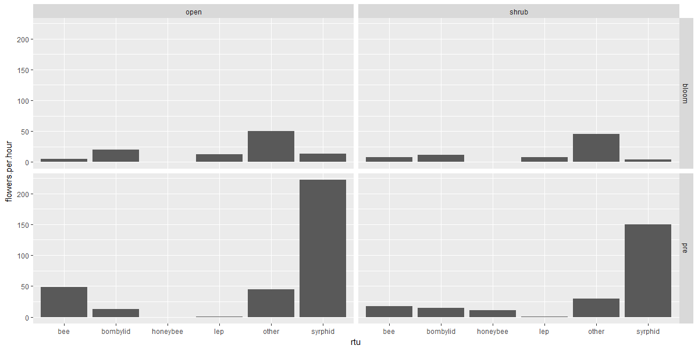

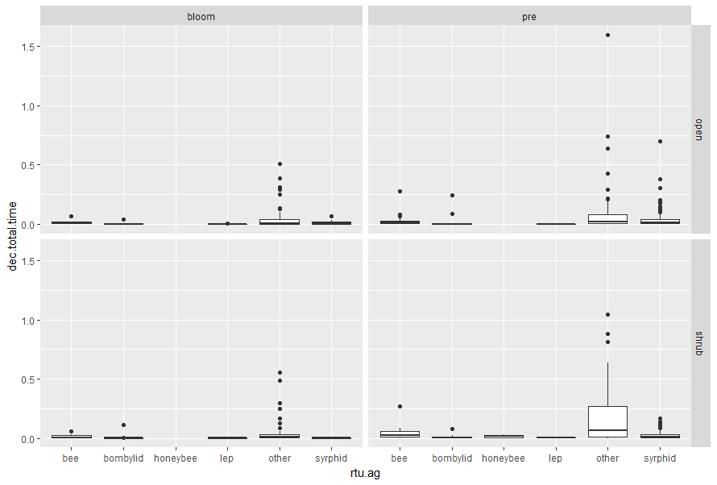

Visitation

The number of flowers and the height of the shrub (Pearson’s, 0.3185, p = 0.03511), number of flowers and width (Pearson’s, 0.462, p = 0.001595) and width and height (Pearson’s, 0.6915, p = 2.02e-07), all tested using cor.test function in r.

|  |  |  |  |
| --- | --- | --- | --- |
|  | Pre-blooming | Blooming | Total |
| All insect uses | 138 | 400 | 538 |
| Uses touching plant | 57 | 232 |  |
| Uses not touching plant | 81 | 168 |  |
| Understory uses | 20 | 15 |  |
| Flower uses | NA | 197 |  |
|  |  |  |  |

The most frequent visitors were bees (115): Apis mellifera (54 visits), Centris rhodapus (35), Hesperapis larrea (30), Eucera sp. (11) and other solitary bees (39) including Hoplitis and Megachile. Visitation by all visitors was positively associated with flower number, height and width. Visitation to larrea much greater. 17.13 floral visits to the plants per hour.

Pan traps

Positive effect of shrub on diversity, negative effect of blooming.

There is a significant correlation of insect abundance between shrub/open microsites (p = 4.41e-07, 0.4576805).

Table: Total arthropod abundance for each treatment

|  |  |  |  |
| --- | --- | --- | --- |
|  | Shrub | Open | Total |
| Pre-blooming | 935 | 973 | 1908 |
| Blooming | 692 | 777 | 1469 |
| Total | 1627 | 1750 | 3377 |

Table 2: Mean ± SD, arthropod abundance per shrub for each treatment, 3 pan traps. Including flower beetles.

|  |  |  |  |
| --- | --- | --- | --- |
|  | Shrub | Open | Total |
| Pre-blooming | 17.31481 ± 7.947526 | 18.01852 ± 10.074235 | 17.66667 ± 9.037823 |
| Blooming | 11.53333 ± 6.217708 | 12.95000 ± 7.601126 | 12.24167 ± 6.951205 |
| Total | 14.27193 ± 7.630035 | 15.35088 ± 9.177678 |  |

Table 3: Total arthropod abundance without Melyrid beetles

|  |  |  |  |
| --- | --- | --- | --- |
|  | Shrub | Open | Total |
| Pre-blooming | 783 | 510 | 1293 |
| Blooming | 435 | 359 | 794 |
| Total | 1218 | 869 | 2087 |

Predatory and parasitoid wasps were more abundant in shrub microsites. Velvet ants were only associated with open sites. No difference in pollinators?

Beetles removed.

GLMM: pretty much all iterations:

Positive shrub effect on abundance, negative blooming effect. Positive temperature effect on non-beetle abundance. Need to learn more about nesting but I am happy with this for now.

Positive shrub effect on diversity, negative blooming effect. Blooming may just be due to sampling effort.

No correlation between visitation and abundance, or diversity from pan traps.

Effects of larrea on vegetation

Because of the study design, blooming and not blooming are also considered for covariates.

Percent cover of ground vegetation was significantly greater in shrub microsites before and after blooming. Prior to blooming, no significant different in annual floral density or plant species richness. Significant decrease in richness and annual floral density with blooming.

Prior to blooming, there was no difference in the number of blooming shrubs in a radius around the shrub and open microsites. There is a significant increase in the number of surrounding shrubs with larrea blooming, and after larrea blooms there is a significant difference between shrub and open sites. Logical given the open sites were chosen to be away from shrubs.

Insect groups

No difference in bee abundance in pan trap with blooming or microsite. Barely caught any syrphids. There was a significant decrease in micro beeflys with flowering.

Discussion

* Larrea influences both plants and insects that it associates with
* Differential effects of the different communities
* No effect on pollinator abundances – thus likely behavioural?
* Just because it concentrates insects doesn’t mean that benefits plants
* Facilitates vegetation growth but competes for pollinators
* Is there a temporal structure to the data?
* Dilution effect – not only was larrea flowering – surround shrubs and cactus were as well
* So yes, there might be a temporal effect but really that effect is of the dominant, foundational plants all flowering, and potentially life cycle shifting of certain pollinators
* What happened to the syrphids?
* Unavailability of rainfall likely prevents annuals from adjusting their phenology. The warmth and moisture required would put a hard limit on when they can flower.
* Lack of correlation between shrub abundances and visitation suggests that differences in visitation driven by something else ie foraging preferences vs concentrating local abundances. They were tested on different days however. But not far apart.
* Lack of visitation to Malacothrix not due to lack of bees – Larrea was visited. If the bees that visited were oligolectic but main visitor to Larrea was the honeybee. A generalist.

Supplemental Data

* All camera stuff with all visitors included, along with model outputs